Northern Jumble
The Important Stuff:
Distance | Registration Open | Race Brief (start line) | Race Start | Towards
Marathon | 8:00 – 9:15 | 9:20 | 09:30 | Huddersfield
20 Miles | 8:00 – 9:15 | 9:20 | 09:30 | Marsden
½ Marathon | 9:15 – 10:15 | 10:20 | 10:30 | Huddersfield
10 Miles | 9:15 – 10:15 | 10:20 | 10:40 | Huddersfield
10k | 10:30 – 11:45 | 11:50 | 12:00 | Marsden
5k | 11:50– 12:45 | 12:50 | 13:00 | Marsden

GETTING TO US:
Registration is at ‘Waves, 5 Upper Mills, Slaithwaite, Huddersfield, HD7 5HA.
The start and finish is just outside he Waves Centre on the side of the canal.
PARKING – PARKING IS VERY LIMITED, YOU CAN PARK ON THE STREETS AROUND THE VILLAGE, IF YOU COULD CAR SHARE THAT WOULD BE GREAT.
CAKES
The waves centre is a charity run organisation and does fantastic work. You will find tea, coffee and cakes available within the centre, if you could kindly make a small donation on the day that would be wonderful. Thank you.
Race Numbers and Registration (and loos):
Race registration will close promptly at the times stated above. We need to make our way to the start/finish area.
Please don’t leave it to the last minute to collect your numbers we want everyone to enjoy their day and stressing in a queue minutes before the race isn’t a great start.
You can drop your bag within the waves centre. All property is left at your own risk.
PLEASE NOTE WITH REGARDS TO TOILETS – ONLY USE THE TOILETS AT WAVES THERE ARE 2 SETS, ON IN THE REGISTRATION BUILDING AND 1 IN THE MILL BUILDING 30 METRES UP THE CANAL (ASK A MARSHAL), PLEASE DO NOT USE THE TOILETS IN THE HOMEMADE BAKERY, UNLESS YOU ARE A CUSTOMER.
THE COURSES
Detailed maps are further down the brief.
Maps available on ‘Grim up North’ Strava
All the courses stay on the canal. If you’re not on the canal tow path then you’re off course or running another race.
The Huddersfield canal is interesting as it has quite a few locks, making the canal surprisingly uphill and then downhill, see if you can count all the locks…
Parts of the towpath can be extremely wet and sometimes muddy if there has been a lot of rain. Parts of the towpath is extremely narrow, please take care.
There are very low bridges on the canal please take care, especially the taller runners. There are cobbles that can be slippery in certain conditions.
There are a few minor roads to cross and one major road to cross in Slaithwaite itself, we will warn you the runner with a sign before you cross and we will warn the road users with a sign that you maybe about to cross. PLEASE TAKE CARE….RIGHT THAT’S ALL THE CAUTIONS OVER AND DONE WITH.

This one is totally dependent on you and the weather prior to the event, the course is predominately traily towpath.
NUMBER EXCHANGE, withdrawal, deferrals, refunds, changes on the day entries.
We have hundreds of entrants to manage on race day and whilst we want you all happy things invariably get hectic at Grim HQ, as a result:
We cannot issue refunds, or defer your entry without 2 weeks’ notice – with the number of races and the effort going into each event it’s just not possible.
We want to try and do everything we can to get you running and so we ask that you also give us two weeks’ notice if you want to transfer your place to another runner or change the distance you are running. However we will TRY to accommodate some of these changes on race day. This will be at the committee’s discretion and numbers will be released 30 mins before race start. This cannot be confirmed beforehand as it is dependent on a number of factors. You will be excluded from a top three award.
There may be a number of entries on the day. This will be at the committee’s discretion and numbers will be released 30 mins before race start. This cannot be confirmed beforehand as it is dependent on a number of factors. You will be excluded from a top three award.
We hope to have a ‘Change and On the Day’ desk, due to limited volunteers there will only be one person staffing that desk so it could get busy and we’d hate you to be late for your race.
DURING THE RACE
We hope to start all the races promptly. Please inform a race official if you are unable to complete the course and need to withdraw for any reason. Please assist officials by making sure your number is visible.
We don’t own the race path on the day please be courteous to other users, smile and try to keep left. The path should easily be wide enough for everyone to use it and we are staggering the starts to prevent congestion.
There is a 6 hours 30 mins cut off for support on the runs. If you think you will take longer than 6 hours 30 mins then you can arrange to start early but the marshals will stand down assuming a 6 hours 30 mins runner. If you think you may take longer then:
- Contact us prior to the event and we can arrange an earlier start.
- Take warm clothing, food and water.
We do not want to spoil the enjoyment of the event for the competitors but we do not endorse the use of I pods or similar devices (bone conduction headphones can be used) for the following safety reasons:
Runners cannot always hear the marshals’ instructions.
Runners may not hear cyclists behind them and stray into their path.
WATER
We are going cup free in 2019 – please help us by bringing your own re-usable cups and/or drink bottles.
Jugged water and squash will be available at all drinks stations, there will also be food on the course. Water will be available approx. every 3 miles and at the start/finish. You may place your own drinks, gels etc. at the water stations, please mark them clearly with your name. Bottled water is available at the end.
Please don’t litter, we run in beautiful locations and it’s always a shame that we have to pick up cups and gel wrappers after every event, have a stern word with yourself.
WEATHER AND CLOTHING
Please keep an eye on the forecast and dress appropriately. We love you and only want the best for you, so, if it’s minus three, snowing and you are dressed in vest and shorts we probably won’t be letting you start. Similarly sun cream is always wise in sunny weather.
SOCIAL vs E-Mail.
Well, we are a very social little group and we love our Twitter and Facebook, there is also a Facebook chat group where you can ask questions such as what trainers to wear, what’s the elevation like, any tips, recommendations, all from other runners as well as ourselves or if you just want to chat, we really recommend you use this rather than messaging/emailing in, as most of the time the query can be resolved on there. At times we get inundated with emails and messages asking the same questions which ties us up and means we can’t deal with things that need dealing with like permits, new race routes and baking cakes and fudge etc.

We really do understand your races are important days to you. We love seeing smiles and watching runners enjoying themselves, that’s why we do it! Please just help us to help you.

MAPS:

ALL MAPS ARE AVAILABLE ON ‘ITS GRIM UP NORTH’ STRAVA
Northern Jumble 5k – from Waves towards Marsden and back.
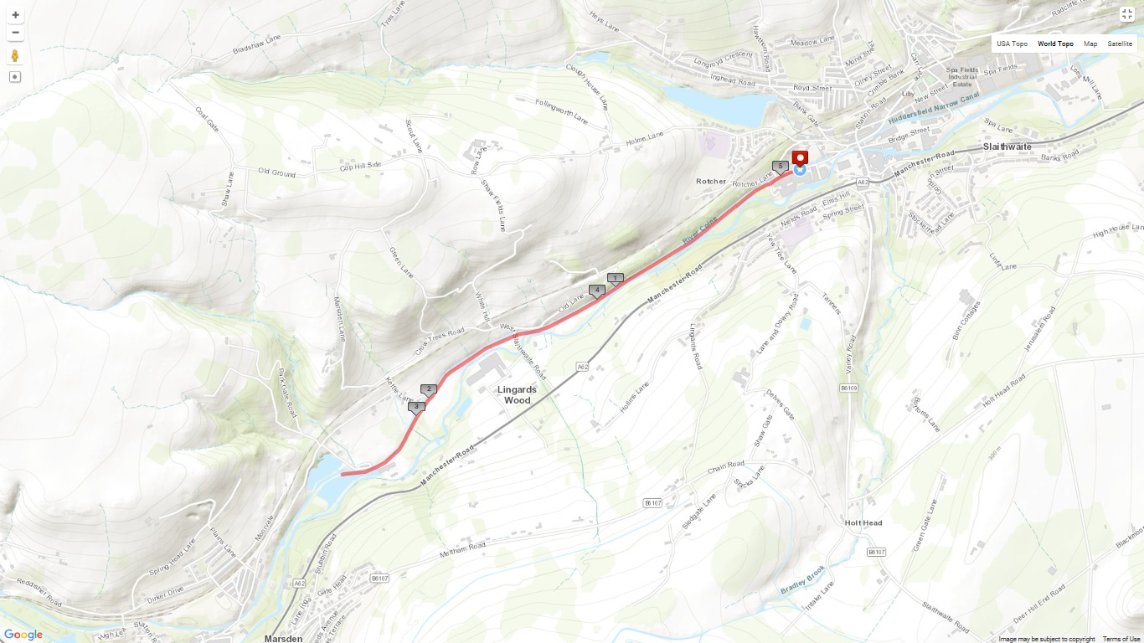

Northern Jumble 10k – From Waves to Tunnel End Marsden and back.
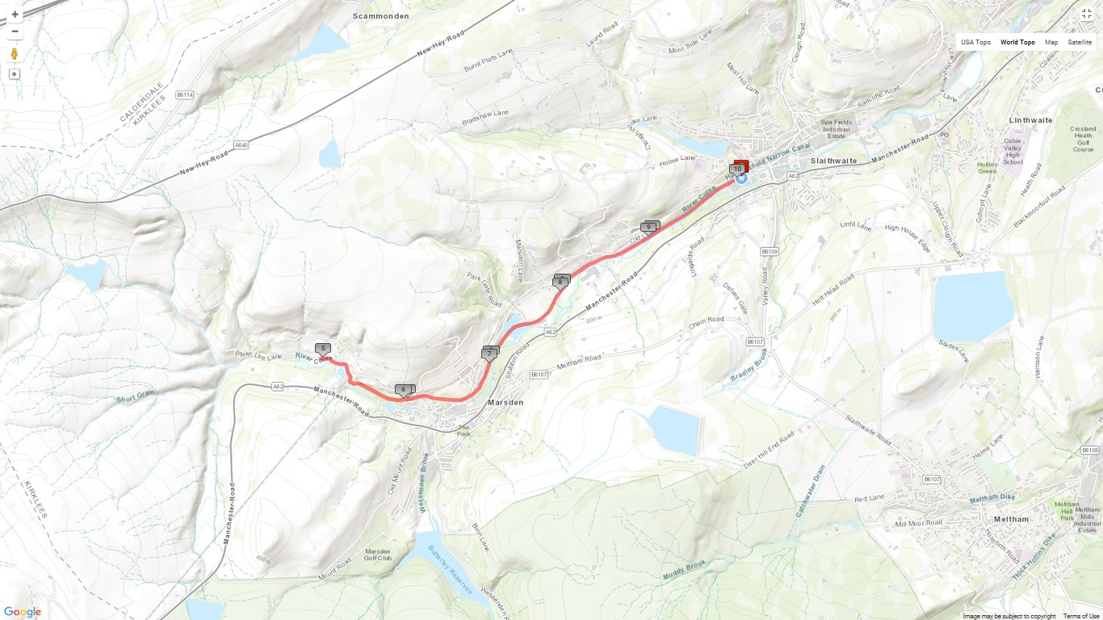
Northern Jumble 10 Miler – From Waves towards Huddersfield, turnaround, back through start and finish area, to Marsden, Tunnel End and back.

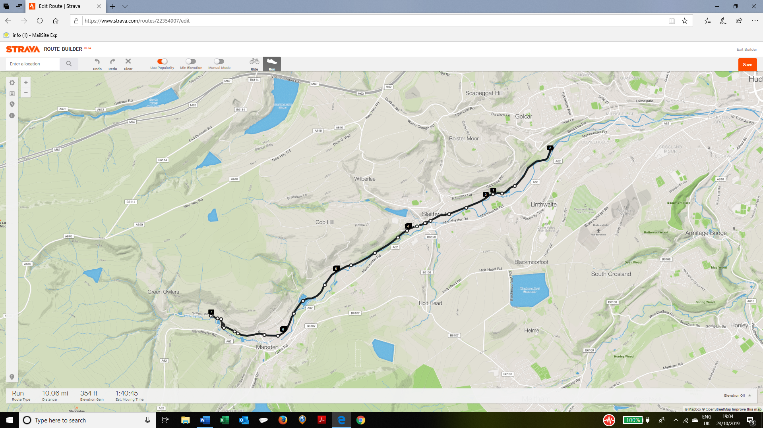

Northern Jumble Half Marathon – From Waves towards Huddersfield, turnaround, back through start and finish area, to Marsden, Tunnel End and back.
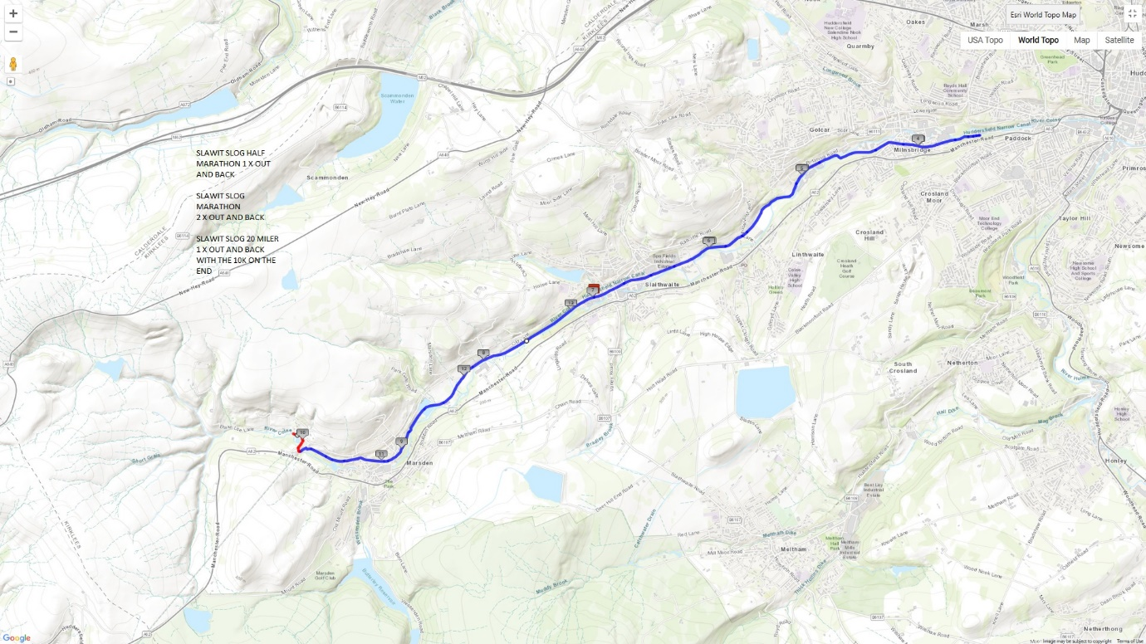

Northern Jumble 20 Miler – From Waves to Tunnel End, Marsden. Turnaround back to start and finish and then follow the half marathon route.

Northern Jumble Marathon route – Is the half marathon route twice

See you on the day.

